## Partner contact info

Organization:Erste Yazilim

Type: Industry/SME/Research/Academia

Name:Özer Aydemir

e-mail: ozer@iotiq.de

Phone #:

## Partner interests within the project

<Please provide a short desctiption of your R&D and collaboration interests and expectations within the OWE4SC project>

Erste, established in Cyberpark Bilkent , Ankara in 2007 , is R&D based multinational SME collaborated with corporates and companies( Bosch, Siemens, Koç sistem etc. ) .Our mainly focuses are IOT technologies and advancements ,video streaming and analysis as wells as mobile applications and framework development. We also bid for state-of-the-art software development projects and will be part of the research project consortia across Europe. Our purpose is mainly offering good and end to end services for our customers and partners. Our projects got awarded several times by respective committees for instance TUBİTAK, KOSGEB and ITEA etc... We use the latest and most advanced technologies( such as JavaScript, NodeJS, ExpressJS, MongoDB, Wowza etc.. ) to satisfy our clients’ expectations from a variety of domains(such as Supply chain, Infrastructure, Health, Energy etc.) and to increase our services quality. We actively participate in Cluster programs such as ITEA3, EUREKA etc. including innovative, industry driven and pre-competitive R&D projects with the purpose of gaining know-how and reinforcing our skills.

## Open Data and Technologies

We have ongoing and completed projects such as (Baas) and Gamma in smart building and meeting areas that might linked to OWE4SC . Gamma , sub product of Baas project, is a collaborative and enriched platform to create most convenient and comfortable environment for our client by establishing heterogeneous network among different devices(such as HVAC, electricity and water etc). Our project, which lies in building distributed control mechanism and eliminating manual operations, mitigate the risks and issues caused by unexpected events and outages in an reliable, secure and interoperable and loosely coupled way. We can contribute to this project with our huge expertise of this domain.

<http://gammaf.herokuapp.com/#/>

## Success Factors/KPIs

<Please describe when you would see the project has been a success for you. Please identify and list relevant KPIs (Key Performance Indicators) from your organizations viewpoint.>

Accuracy and precision of methodologies and algorithms.

Seamless integration of devices.

Maintainance of system interoperability with loosely coupled architecture.

The minimization of network faults

Establishing reliable and quick communication among devices in real time.

The quick recovery and back-up of the system with minimum human intervention.

The flexibility to extend new features in the system.

## Background

Please list previous R&D projects you see relevant regarding OWE4SC project as background/collaboration possibility:

|  |  |  |  |  |
| --- | --- | --- | --- | --- |
| Project Name | Cooperative Programme | Time period (approx.) | Technical Focus | Relationship |
| <BaaS > | <ITEA3> | <2012> | < The main basis of Baas is technological production focused on smart buildings and smart environment with IOT technologies. Within this project,  Baas aims to build integrated services on the environment to eliminate time or operation related problems and risks based on human work within constrained time.  > | OWE4S project can be categorized as extended version of Baas by employing AI and machine learning based methodologies, all objects in the environment(including sensors, actuators and device)s can communicate each other more seamlessly, secure and feasible. |
| <Gamma > |  | <2015> | Gamma aims to build up smart meeting room to create more convenient as well as comfortable environment for the people by mediating heterogeneous networks and diverse devices. There is no such a platform providing all the external systems integration. All the data transfer and exchange is accomplished via distributed systems instead of centralized which mitigates a massive amount of data trafficking and network latency. | OWE4S can cover some functionalities being similar to Gamma Project( for example 2D environment modelling, layering and commissioning as well as floor modelling ). The way to build up open source platform and integrated services can be used as mainly basis in some extent. |

Please indicate any relevant publications (scientific papers, white papers, etc), which you see relevant for the OWE4SC project as background information:

* <publication info, link>

Please indicate any relevant market study you see relevant for the OWE4SC project objectives:

* [https://www.mckinsey.com/~/media/mckinsey/industries/capital%20projects%20and%20infrastructure/our%20insights/voices%20on%20infrastructure%20turning%20the%20smart%20city%20opportunity%20into%20reality/voices-december-2017-web.ashx](https://www.mckinsey.com/~/media/mckinsey/industries/capital%20projects%20and%20infrastructure/our%20insights/voices%20on%20infrastructure%20turning%20the%20smart%20city%20opportunity%20into%20reality/voices-december-2017-web.ashx%20)
* <https://ww2.frost.com/files/8715/1248/3558/SmartCities_-_Nov_2017.pdf>
* Medagliani, Paolo & Leguay, Jeremie & Duda, A & Rousseau, Franck & Duquennoy, Simon & Raza, Shahid & Ferrari, Gianluigi & Gonizzi, Pietro & Cirani, Simone & Veltri, L & Montón, Màrius & Domingo Prieto, Marc & Dohler, M & Villajosana, I & Dupont, O. (2014). Internet of Things Applications - From Research and Innovation to Market Deployment.

## Collaboration

<Please describe what kind of collaboration and networking benefits and added value your organization is looking for by participating the project. Please consider both business and technological viewpoint.>

## Outputs

<Please describe outputs (novel algorithms, standards, open source libraries, implemented collaborative framework, demonstrator, product prototype, new service based on some software, wearable device, etc.) that you organization can create/contribute to during the project.

## Role of the partner

## We would like to contribute more the parts related to data management and governance, creating AI based framework and applications and defining cyber physical systems. We would also like to participate in reference architecture and system modelling with our IOT project based expertise.

## Innovations and Standards

<Please list any relevant innovations and standards regarding the project from you organization perspective. Please identify any relevant standardization organizations that your organization is participating.>

## Value chain positioning

<Please describe positioning of your organization in socio-cyber-physical value stream and markets illustrated in Figure 1 below>

**Relevant markets of the socio-cyber-physical value stream for my organization:**

* <Please list>

**Positioning in the socio-cyber-physical value stream:**

<Please describe the added value your organization can bring within the value stream. What kind of organizations you envision as customers for your offering and on which markets? Which markets you need to participate and what kind of organizations you need to co-operate with to be able to provide your envisioned offering?>

With the advancement of technologies and increase in people demand, creating smart environment in different domain will

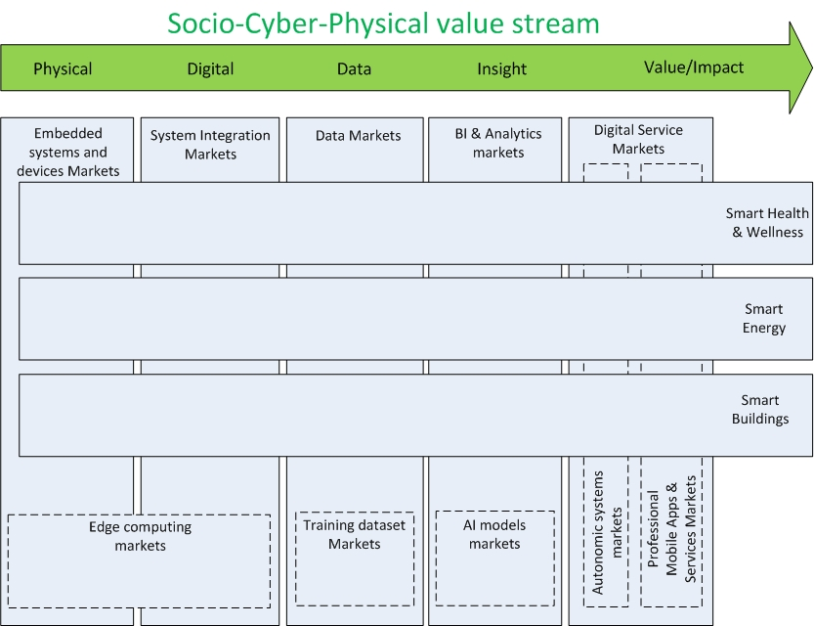

**Figure 1. Socio-Cyber-Physical value stream, related markets and application domains**.